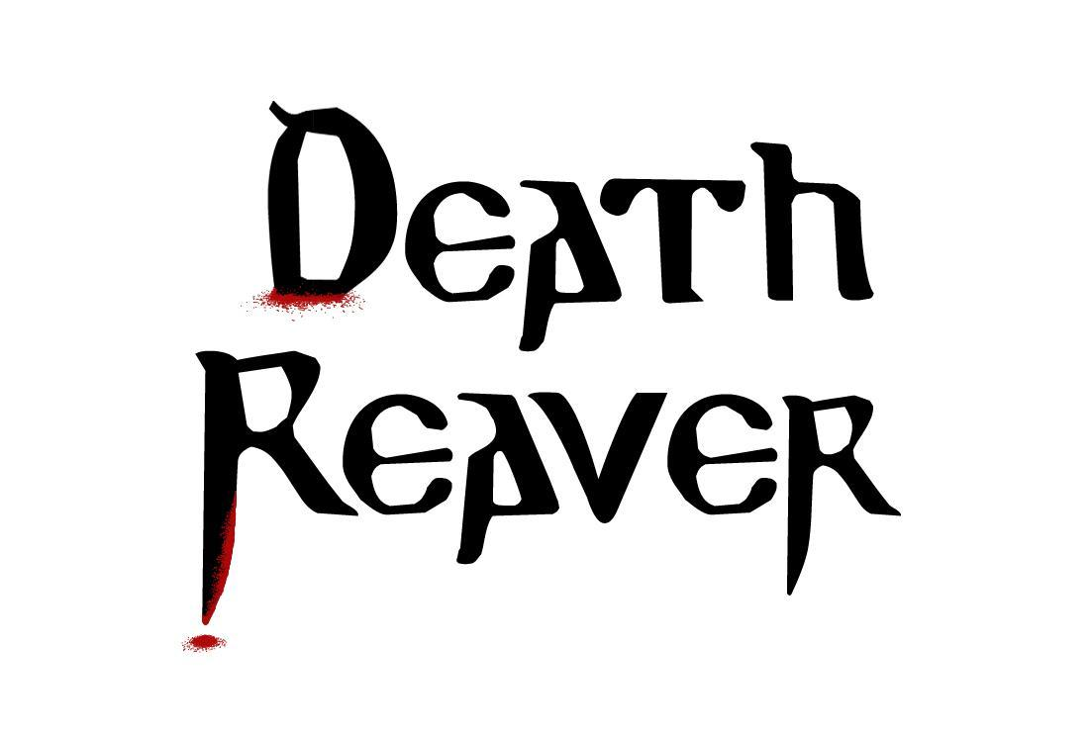

**Game Design Document**

HORSEMEN

V 1.0

|  |  |  |
| --- | --- | --- |
| **Team Roster** | | |
| **Position** | **Name** | **Signature** |
| Designer / Artist | Nicholas Hunter |  |
| Artist | Aundray Oritz |  |
| Artist / Animation | Jared Bittner |  |
| Artist | Ryan Tonks |  |
| Artist | James Countryman |  |
| Programmer/ Designer | Ian Smith |  |
| Executive Producer | Gideon Shbeeb |  |

**Document Revision Table**

|  |  |  |  |
| --- | --- | --- | --- |
| **Version** | **Updates** | **Advocate** | **Date** |
| 1.0 | Initial Document | Nicholas Hunter | 02/21/15 |
| 2.0 | RTM Submit | Nicholas Hunter | 04/29/15 |
|  |  |  |  |
|  |  |  |  |

**Table of Contents**

Concept 3

High Concept 3

Game Description 4

Game Features 4

Genre and Location 4

Style 4

Combat 4

Leveling and Class 4

Story 4

Story Synopsis 4

Backstory 5

Character Stories 6

The Gods 6

Souls 6

The Demigods 6

Kara 7

Duru 7

Humanity 7

The Twins 7

Return of The Gods 8

The Human Uprising 9

The Suicide of Kesh 9

The Corruption of Kesh 10

The United Rule 10

Gameplay 11

Overview 11

Player Objectives 11

Core Gameplay Mechanics 11

Movement 11

Camera 12

Player Combat 12

Character progression 12

Player Health 13

Player Death 13

Metrics 13

Default Player Values 13

Talents 14

Controls 16

List of NPCs 16

Software Level Systems 21

Interface 21

Menu Screens 21

Main Menu 22

Pause Screen 22

Character Talent Sheet 22

Game Over 23

Controls menu 24

HUD 24

Stats panel 24

Environment 25

Level Breakdown 25

Museum Lab 25

Museum Interior 25

Museum Exterior 26

# Concept

## High Concept

The player commands an ancient and powerful demigod, and cuts their way through a museum, absorbing the souls of victims, and gaining power to evolve the player’s weapons and armor.

## Game Description

**Game Goals**

* Provide the player with other-worldly strength and power through melee combat and ancient god-like abilities.
* Create a sense of superiority through dominating lightly armed humans.
* Require a small level of skill to counter the attacks of powerful humans with advanced modern technology of the time.

## Game Features

### Genre and Location

* Isometric hack and slash set in New York in the early 1950s.

### Style

* The player brings darkness and grit to an otherwise iconic and average depiction of 1950’s American culture. The art aesthetics are low-poly and basic shaded textures.

### Combat

* Combat is brutal and fast paced, as the player’s attacks are accentuated with other-worldly effects.
* Killing foes nets the player souls to reap and are spent on unlocking new talents.

### Leveling and Class

* The player’s weapon evolves into new shapes as the player selects various talents and perks.
* Talents and perks help accentuate the player’s preferred play-style, such as ranged damage, area of effect damage, increased direct damage, and crowd control.

# Story

## Story Synopsis

A recently resurrected demigod uses his ancient sword to seek vengeance on humanity and surviving demigods of the past in 1950’s New York.

## Backstory

12,000 years ago, the sons and daughters of gods ruled the kingdoms of man. The eldest among them ruled over all others; Kesh, and his twin sister Larsa.  For centuries, there was order and obedience on earth, as the gods had planned. As mankind developed and grew to better understand the world around them, their natural curiosity lead to new technologies and pleasures of life. The demigods’ struggled to maintain control over mankind and their new discoveries, as some began to partake in the temptations of man. This spurred a power struggle between the twin brother and sister, as they attempted to maintain control over the lesser demigods and mankind alike.

Kesh saw his brothers and sisters derelict their duties as rulers over man, and sought to gain control of their human colonies and bring them back in line with the commands of the gods. Larsa saw the creations of man as a tool to be harnessed and exploited, for the pleasures of ruling while awaiting the gods’ return. Their differences of opinion eventually lead to open conflict between the pair, resulting in two factions of demigods and their human colonies which they commanded. Each faction dealt with the creations of man as they saw fit, and fought against each other over land and resources. Kesh set his army upon the colony of Larsa, resulting in large losses of human life, forcing the gods to intervene.

To quell this conflict between their children, the Gods forged twin blades capable of devouring the souls of those who are slain, and empowering the weapon's wielder. The gods hoped these blades would teach the demigods a lesson in humility and bargaining. Each twin was given a blade - bound to their own soul - and thus caused an uneasy stalemate; no demigod was willing to lose their immortality to the blades power. Open conflict and loss of human life gave way to debate and bargaining – the god’s plan had worked.

Centuries of unstable peace between the demigods went by, while man’s intellect continued to flourish. Mankind began to grow tired of the demigods arrogance and rule. After being denied liberty by the demigods in a formal request, unrest and rioting became common among the colonies of man. Humanity secretly hatched a plan to steal the twin blades and use them to threaten the demigods into releasing humanity from their rule.

Kesh, overburdened by disdain for Larsa and his other siblings who refused to see the world his way, sought to end his existence on Earth the only way he knew how; the blade given to him by the gods. He enlisted the aid of Kara, his younger and most loyal sister, to assist in hiding his body and the blade once he was dead. Kesh and his sword were lost for millennia. As a result, Larsa and her followers gained dominance over those loyal to Kesh, and their rule was unopposed.

In the early 1950’s, an American archeology team uncovers the mummified remains of Kesh, with his sword still lodged in his chest. The body of Kesh and the various items Kara buried with it were packed up and shipped to a museum in New York for study. A large exhibit was built in honor of the event, and many visited the museum that day to see a live autopsy of Kesh’s corpse.

The scientists first removed the blade from his chest, and thus allowed for the soul of Kesh to escape the blade and return to his emaciated body. Kesh quickly took the blade from the hands of a nearby scientist in shock, and turned to dismount the operating table.  
  
 This is where the game begins.

## Character Stories

### The Gods

Creators of the universe and all within it. Worlds are forged and razed as the gods experiment with their powers of creation and destruction. They hold the keys to the universe, and the knowledge of it’s very essence. Nothing is sacred to them; death, strife, life, love - all are things to be studied and learned from. They do not see the future, and they do not have a divine plan, but they observe all that happens with life in the universe. They create and observe, and sometimes intervene, but everything to them remains a chance to learn.

They do not let their creations know of their true understanding of the universe. They only tell their creations what they want them to know, to better influence the outcome of their experiment.

### Souls

All life in the universe is forged by the gods from the same energy source. Every human, demigod, animal, and plant on earth have their physical forms animated and given life through this energy. Upon death, the physical form ceases to function, and decays away, breaking down into basic molecules and elements; waiting to once again become a part of the cycle of life. The soul - the very essence of the energy of life - is returned to its source, along with all it had experienced and learned. As the wealth of knowledge and experience of life builds, the universe expands in size. Humans know this force as dark energy, but have yet to understand its secrets.  
  
The gods use the physical elements of the universe as vessels to house this soul energy, so that it may experience and record life, and then return to the source for study. This is how the gods keep informed on their creations.

### The Demigods

Created by the gods as administrators, the demigods are immortal; designed to unconsciously absorb a constant flow of soul energy from the universe around them to maintain their bodies. They were given instructions by the gods to rule over humanity and maintain an order. Demigods are intelligent, but their immortality makes them unmotivated and unimaginative; they have their purpose, and that’s all they care about. They are physically stronger than humans, and their physical form heals almost instantaneously.

### Kara

The youngest sister of Kesh and Larsa. She has sword her allegiance to Kesh, and is his most trusted and loyal sibling. With no direct colony under her control, she assists Kesh in maintaining order within their own colony.

### Duru

One of the many demigods under the command of Larsa. In modern times, he is in a position of command over the humans of north east North America.

### Humanity

Created by the gods as the main test subjects on Earth, humans were given a special aptitude for creativity. Their short lifespan and curiosity about the universe around them led them to develop science and technology. Their skills not only helped them to unravel the secrets of the universe, but to also create pleasures and time saving devices. This unique attribute was purposefully not mentioned to the demigods.

After millennia of growth and development, and the human casualties of the sibling conflict, humanity began to see the demigods as unnecessary rulers. The demigods took the creations of man and used them for themselves. Factions emerged as the demigods fought over how to deal with the creativity of humanity; breaking the population up into kingdoms under their control. Humans were still susceptible to propaganda, and tribal mentality of groups simply defined by their geographical location, much like sports fans in modern times.

### The Twins

The fastest and strongest; they are the eldest of demigods on Earth. The pair were created by the gods to maintain order on Earth, and rule over humanity and the lesser demigods.

#### Kesh

Main character of the game. The role the player assumes.

Kesh is the twin brother of his sister, Larsa. Kesh is a stalwart defender of the commands laid upon the demigods by the gods: maintain order through rule. Kesh believes the humans should be free to create and behave as the gods created them, so long as the demigods maintain order on Earth and rule the societies of man. Kesh sees his brothers and sisters disobeying the commands of the gods and grows increasingly angry over several centuries of enduring it. They fight over who commands the most creative of the humans. They indulge in the pleasures developed by the humans. They grow arrogant and apathetic towards the commands of the gods, and this infuriates Kesh.

#### Larsa

Larsa is the twin sister of her brother, Kesh. Larsa sees the humans and their creations as a thing to be harnessed and ruled. The commands of the gods, “Maintain order through rule”, are too ambiguous to not assume that the creations of humanity are also meant to be controlled. If any form of order can be maintained while also using the creativity of humans to benefit the existence of the demigods, why should that not fit within the god’s commands? Larsa is more clever than her brother in this regard; she is willing to question and bend words, where her brother is not.

#### The Sibling Conflict

Kesh saw that his siblings were failing to maintain rule over their human colonies. Demigods became lazy and arrogant - allowing petty crimes and exploitation to thrive within the human colonies. Their solutions to problems were blunt, often resorting to executions without investigation or trial. They viewed the problems of humanity too lowly to be bothered with, while they themselves coveted the technologies and pleasures of man.  
  
This enraged Kesh. To solve this problem, Kesh formed an army of humans to raze the colonies of his brothers and sisters who had forsaken their duties. He and the few siblings who held his views went to war in an all-or-nothing attempt to get Earth back on track with the plans of the gods.

The first target Kesh set his eyes on was the human colony under rule of Larsa. Kesh and Larsa set their forces against one another, resulting in large losses of human life as the demigods cut through the armies of man. This conflict was cut short by the return of the gods.

### Return of The Gods

The gods returned to earth in an attempt to quell the conflict between the demigods. Rather than speak with their creations and guide them through reasoning, a means of mutual destruction was provided to each twin. The gods had forged twin blades, capable of devouring the souls of their victims, whether immortal or not. Upon taking the blades from the gods, each twin became soulbound to their respective weapon; any soul devoured by the blade would empower its soulbound twin. This helped deter other users from wielding the weapons.

Whether the demigods slew each other or forged a peaceful truce, the gods ultimately did not care.

Faced with death, the demigods were discouraged from open conflict. Kesh and Larsa took their new weapons and armies and returned to their respective colonies in an uneasy truce.

### The Human Uprising

The Sibling Conflict became an important learning experience for humanity. Centuries later, human scholars and leaders observed the arrogance and gluttony of the demigod rulers, and looked back on the Sibling Conflict in anger. Over mere decades, the general census among humanity was to succeed from the rule of demigods, as they brought nothing but strife and conflict onto humanity. The personal squabbles among their siblings were more important than dealing with social problems such as crime and disputes among the colonies that they supposedly ruled over.

The demigods refused humanity their freedom, citing the command of the gods as their reasoning: humans are to be ruled.  
  
To take their freedom by force, the humans could only take one course of action: steal the twin blades. With the blades in their possession, the humans would have a powerful bargaining chip. But with the suicide and loss of Kesh and his blade, Larsa was emboldened in her efforts to lead Earth in the direction she saw fit. She held her weapon closer than ever, and used the threat of its power to sway her remaining siblings to her side. She now had all the power.

### The Suicide of Kesh

Kesh is so distraught that the gods came back and only offered 2 swords, rather than further instruction and clarification, that he slowly begins to fall into depression. Over centuries, his once loyal siblings who fought with him have begun to degrade into slacking and undutiful rulers. Human unrest and outright riots for liberty began happening often, and there was no way he could do anything about it with so few demigods willing to share his perspective. Kesh knew that the only way he can truly die is to fall by one of the swords having such a hatred for his sister that he would not want to give her the pleasure, and resenting the gods for abandoning him, he entrusts Kara to hide his body and his sword once he kills himself with it.

### The Corruption of Kesh

Kesh’s soul spent thousands of years trapped within the blade. The blades power attempted to bind his own soul with itself, causing nothing but agony. Alone and in pain, Kesh spent the millennia only thinking about his past; the hatred he had for Larsa and the gods. If he were to ever escape this prison, he would destroy everything the gods had ever created.

### The United Rule

The demigods ruled under one united idea; maintain order through rule, and adapt the human’s creations to better rule. Attempts at controlling the creativity of humanity meant that the demigods would have to hide their existence and work in secret; overt rule and control meant that humans would develop a hatred and mistrust for the demigods. To keep control over the humans and also remain largely undetected, the demigods entrusted their most loyal servants to the task of taking leadership positions among mankind. These servants and their bloodline would rule throughout the ages while enjoying the pleasures of rule but also remaining subservient to the demigods. The demigods experimented with various methods of command structures which involved warlords, kings, false gods, religions, governments, and so forth. But only recently within the last several centuries, had they found a working formula for success.

Allowing the humans to live in supposed freedom yielded the best results. Rather than forcing humanity into specific tasks and rolls, the demigods structured government to allow humans to choose their own creative path in life, but still remain subservient to the power structures around them. As a result, humanity experienced and industrial revolution. And soon later, the beginnings of a technological revolution.  
  
The demigods allowed the humans to have their separate opinions and even their wars, while knowing that new and better technology to harvest would result from the winners. And only recently had Larsa seen the opportunity to gain even more power by allowing the humans to study her sword, and develop new technology based on its power. This technology would be used to assist the Demigods in achieving the powers of the gods themselves: omnipresence, omniscience, and omnipotence.

# Gameplay

## Overview

The player takes control of a recently resurrected demigod who’s seeking to settle a vendetta thousands of years old. The player cuts through human enemies while gaining fury to spend on even more powerful attacks. To access new talents which supplement the player’s power in combat, the player absorbs the souls of dead foes into their weapon. These souls are spent in the talents menu.  
  
The player learns to avoid and mitigate damage done by enemies through a series of animated visual cues which the enemy character models display during combat. Along with learning to avoid these attacks, the player learns which talents and attacks best fit their desired play style, and which ones best counter specific enemies.

## Player Objectives

|  |  |
| --- | --- |
| **Level** | **Primary Objectives** |
| Museum – Operating Room | Kill the science team, and unlock the first talent. |
| Museum – General Building Areas | Find Kesh’s armor, harvest souls, exit the museum |
| Museum – Exterior | Fight through the driveway, win the game. |

## Core Gameplay Mechanics

### Movement

* Pointing the cursor, and clicking the left mouse button onto a pathable plane directs the player’s character model to that location. Clicking and holding the left mouse button, while dragging the cursor over a pathable plane, updates the player character model’s path and movement direction.
  + For example:
    - The player character model is always “chasing” the mouse cursor when the left mouse button is clicked or held down.
  + Base movement speed for the player is 2.5 meters per second in all directions.
  + The player character model remains in the center of the screen at all times, as the camera is focused and locked on the character model.

### Camera

* The camera is locked to the player character model at all times during gameplay, while rotated 40* left on the Y axis, with the rotation X axis tilted downwards at a 50* angle.
* The camera is set 10 meters away from the player model, while maintaining that the player model is centered in the camera’s view.

### Player Combat

#### Attacking

* Basic melee swing
  + Animation of weapon swing, dealing physical damage to the enemy being clicked on.
  + Attacks are initiated by left clicking the cursor over an enemy while said enemy is within range of the attack.
* Special attacks
  + Unlocked through talent choices made by the player.

#### Defending

* Roll
  + Roll out of harm’s way in the direction of movement.
    - roll a distance of 3.5 meters in 1 second.
    - can not roll more than 1 time in 2.5 seconds
* Block
  + Use the main weapon to block incoming attacks and mitigate incoming damage.
  + Denoted by a green shield icon above the player model for the duration of the ability being pressed.
    - By default, melee damage which is blocked by the player is reduced by 50%.
    - Blocking is achieved by holding the right mouse button down. All damage taken during this period is reduced by the block reduction amount, as dictated by base metrics and any talent choices of the player.

### Character progression

#### Talents

* + Collect souls by defeating enemies.
    - Souls are visually tracked via the Soul Bar on the HUD.
    - Souls fill the bar until 100% full, and earn a point to spend on a new talent, located on a lower row in the Talents Screen
    - The soul bar rolls over from 100% to 0% when a new point is earned.
    - Unlock new attacks for the player to use in combat
      * Select 1 unlocked talent available on each row of the player progression menu.

### Player Health

* Health amount
  + Default health is 300 units
* Health bar
  + Decreases as the player takes damage.
  + Recharges at a rate of 3 health points per second.
  + If a value of zero is reached, the player dies.

### Player Death

Upon player death, the death screen displays. The player is given the option to replay the game, or go back to the main menu.

## Metrics

### Default Player Values

|  |  |
| --- | --- |
| Health | 300 |
| Movement speed | 2.5 meters per second |
| Size | 2.5 meters tall |

Basic Melee Attack

|  |  |
| --- | --- |
| Speed | 1 attack every 1.5 seconds |
| Damage | 110 |
| Range | 2 meters from the player character model, in an arc from 340*, through 0*, to 20* |

Defense

|  |  |
| --- | --- |
| Blocking | Reduce damage taken by 50% |
| Rolling | Speed is 3.5 meters in 1 second. |

### Talents

Unlocking subsequent tiers following the specialization tree is referred to the total number of souls that are required to unlock the next tier.

* Here is an example scenario. The total number of souls collected is denoted in blue:
  + The player has just started playing, and has collected 0 souls throughout the game (0)
  + The player kills 4 scientists, and collects 4 souls, thus unlocking access to the specialization tree. (4)
  + The player selects a specialization.(4)
  + The player kills 16 Security Guards, and collects 16 souls, thus unlocking access to the Tier 1 talent tree. (20)

#### Specialization Tree

* 4 souls to unlock

|  |  |  |
| --- | --- | --- |
| Mace_spec | Sword_spec | Staff_spec |

* Mace_spec
  + Weapon becomes a Warped Mace
  + Basic melee damage + 20%
  + Health increased by 200
* Sword_spec
  + Weapon becomes Warped Sword
  + Basic melee attack range increased to 2.5 meters
  + Attack speed increased to 1 attack every 1.2 seconds
* Staff_spec
  + Weapon becomes Warped Staff
  + Blocking decreases damage taken by 60%
  + Movement speed increased to 2.8 meters per second
  + Basic melee attack range increased to 3.5 meters

#### Tier 1

* 20 souls to unlock

|  |  |  |
| --- | --- | --- |
| Toughness | Determination | Might |

* Toughness
  + Increase the player’s health regeneration by 3 points per second.
* Determination
  + Decrease the time it takes to initiate a basic melee attack by 0.2 seconds.
* Might
  + Increase the damage of a basic melee attack by 10%

#### Tier 2

* 50 souls to unlock

|  |  |  |
| --- | --- | --- |
| Charge | Drive | Stalwart |

* Charge
  + Deals 250 damage
  + Usable every 15 seconds
  + The player character model moves forward 10 meters in 1 second.
  + All enemies within 2 meters of the player character model during this ability take damage
* Drive
  + Send a wave of force forward from the player, dealing 150 damage to all enemies within 5 meters.
  + Useable every 20 seconds
* Stalwart
  + Deals 60 damage every 0.5 seconds for 4 seconds to all enemies within 2 meters of the player
  + Usable every 20 seconds

#### Tier 3

* 75 souls to unlock

|  |  |  |
| --- | --- | --- |
| Unbreakable | Warp | Reaver |

* Unbreakable
  + Usable every 60 seconds.
  + Become immune to damage for 15 seconds
* Warp
  + Deals 150 damage
  + Has 3 charges, each with a 45 second cool-down.
  + The player character model teleports 4 meters in the direction of input via the left mouse button.
  + Upon teleporting, all enemies within a 3 meter radius of the final location, with the player at the center, takes damage.
  + Damage dealt is transferred to the player as health.
* Reaver
  + Usable every 60 seconds
  + Increase all damage dealt by the player by 40% for 15 seconds.

### Controls

|  |  |
| --- | --- |
| Move | Left mouse button + Left mouse button (hold) |
| Roll | Space bar + Direction |
| Block | Right mouse button (Hold) |
| Melee | Left mouse button |
| Use talent 1 | 1 or Num 1 |
| Use talent 2 | 2 or Num 2 |
| Character menu | C |
| Pause screen | P |
| Controls | Esc |

### List of NPCs

#### Unarmed Human

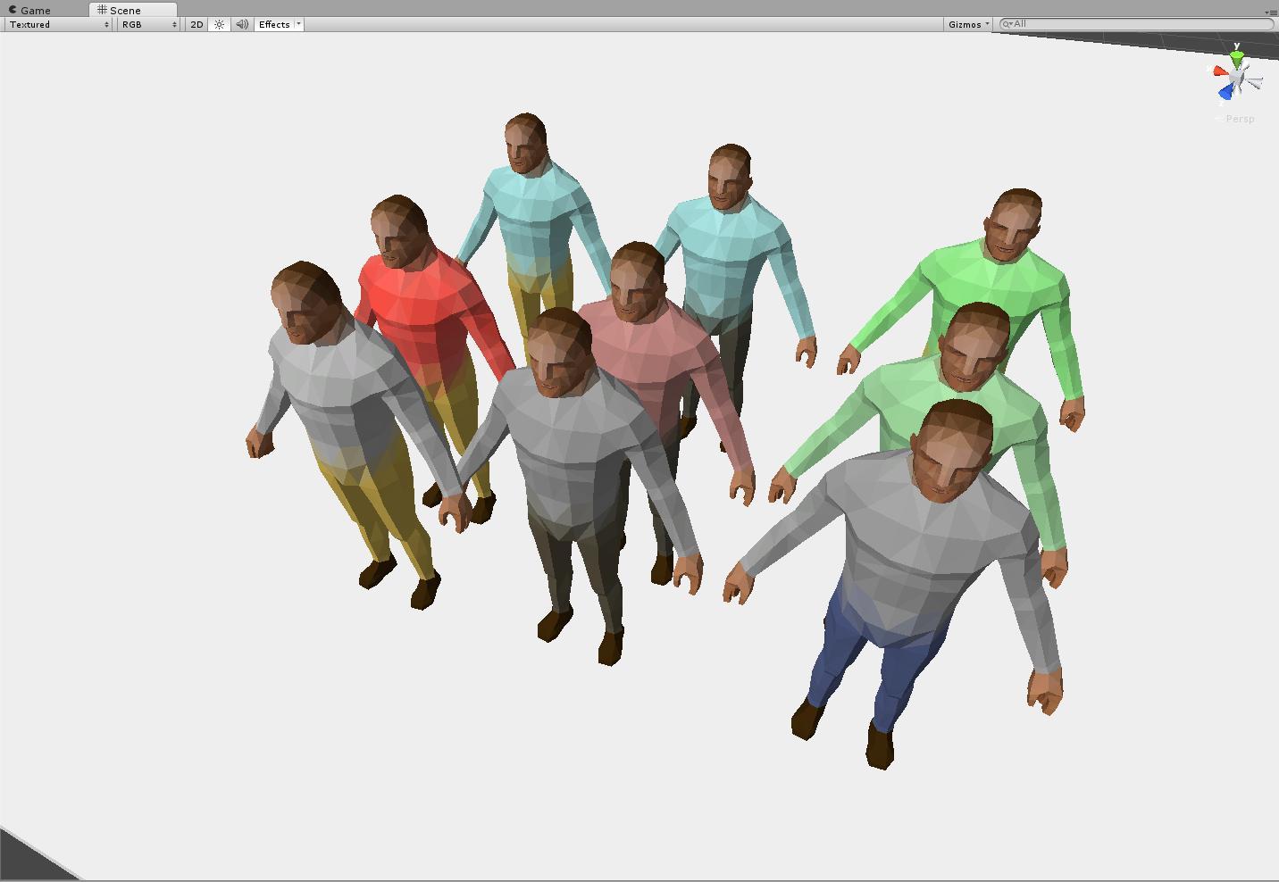

Figure : common appearance with nothing denoting authority.

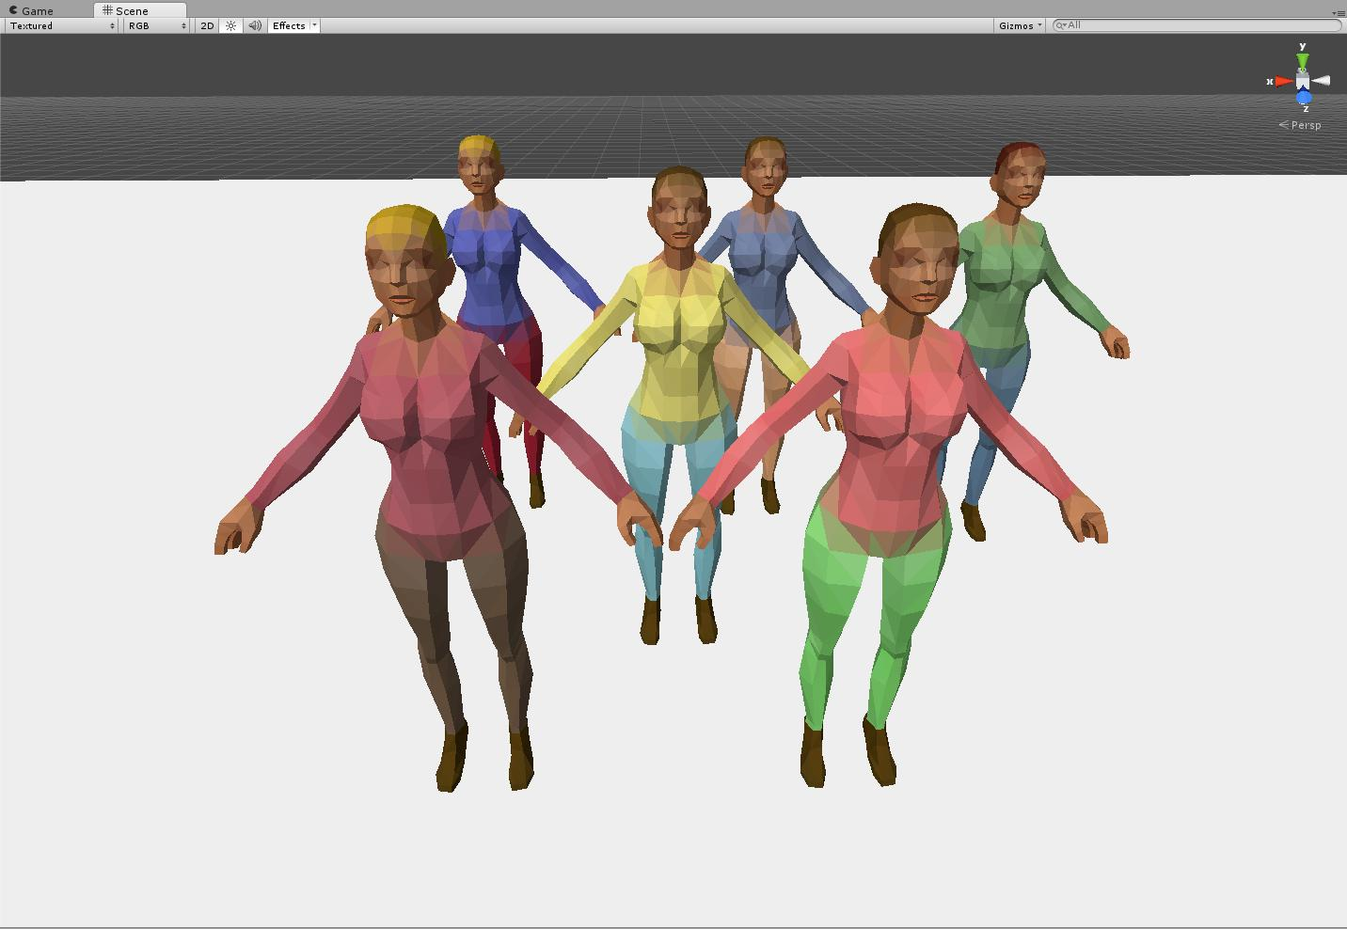

Figure : Common appearance with nothing denoting authority.

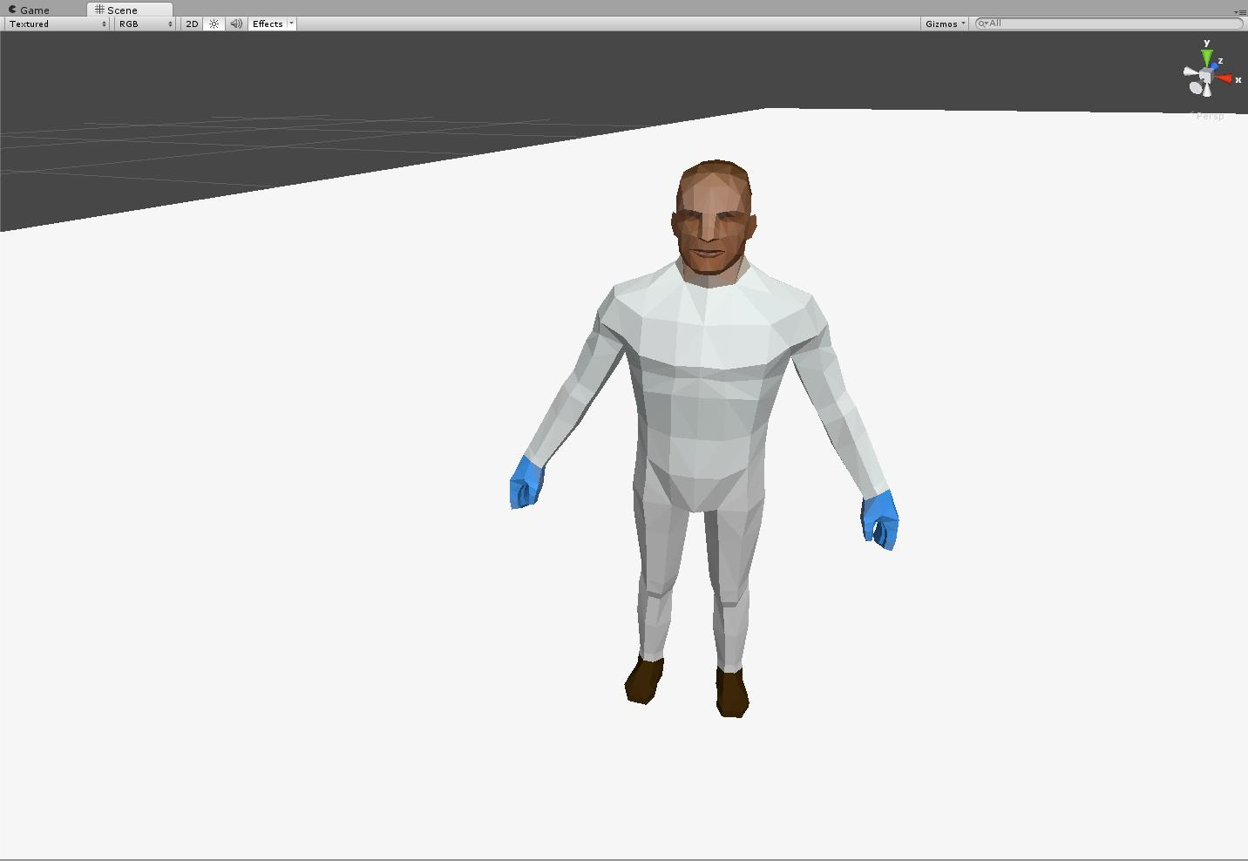

Figure : Scientist

* Height
  + 1.8 meters tall
* Movement
  + Moves at a rate of 2 meters per second.
  + Periodically stops to crouch and cower.
* Attacking
  + Incapable of attacking.
* Defending
  + Runs from the player if the player is within 10 meters.
    - Will run to a point 25 meters away from the player
* Hitpoints
  + 110
* Death
  + Awards 1 soul to the player upon death.
  + Character model is destroyed and replaced with gore pile.
* Variants include:
  + Museum_patron_male
    - 9 color variations
  + Museum_patron_female
    - 6 color variations
  + Scientist

#### Security Guard

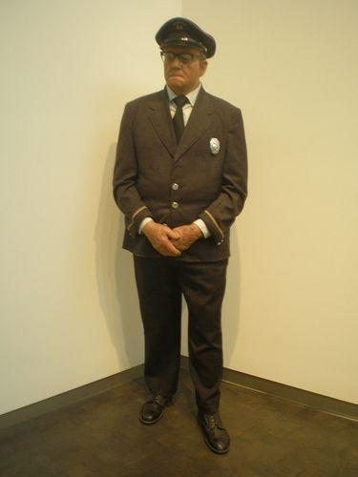

Figure : Professional and neat brown coat and pants. Very authoritative looking, but far too formal for "street" work. Similar to police, but meant to be looked at and recognized as part of an institution.

* Height
  + 1.8 meters tall
* Movement
  + Moves at a rate of 2 meters per second.
  + Chases the player if within 20 meters of the player.
* Attacking
  + Armed with a baton
    - Attacks once every 2 seconds if within 2 meters of the player
    - Attacks deal 10 damage
    - Damage is dealt in a 180* arc in front of the character model, with a range of 2.5 meters, dealing damage if the player is within.
      * For example, this arc - from the Security_Gard’s perspective - is drawn from its left side at 270* azimuth, to 90* azimuth.
* Hitpoints
  + 125
* Death
  + Awards 1 soul to the player upon death.
  + Character model is destroyed and replaced with gore pile.

#### Cop Melee

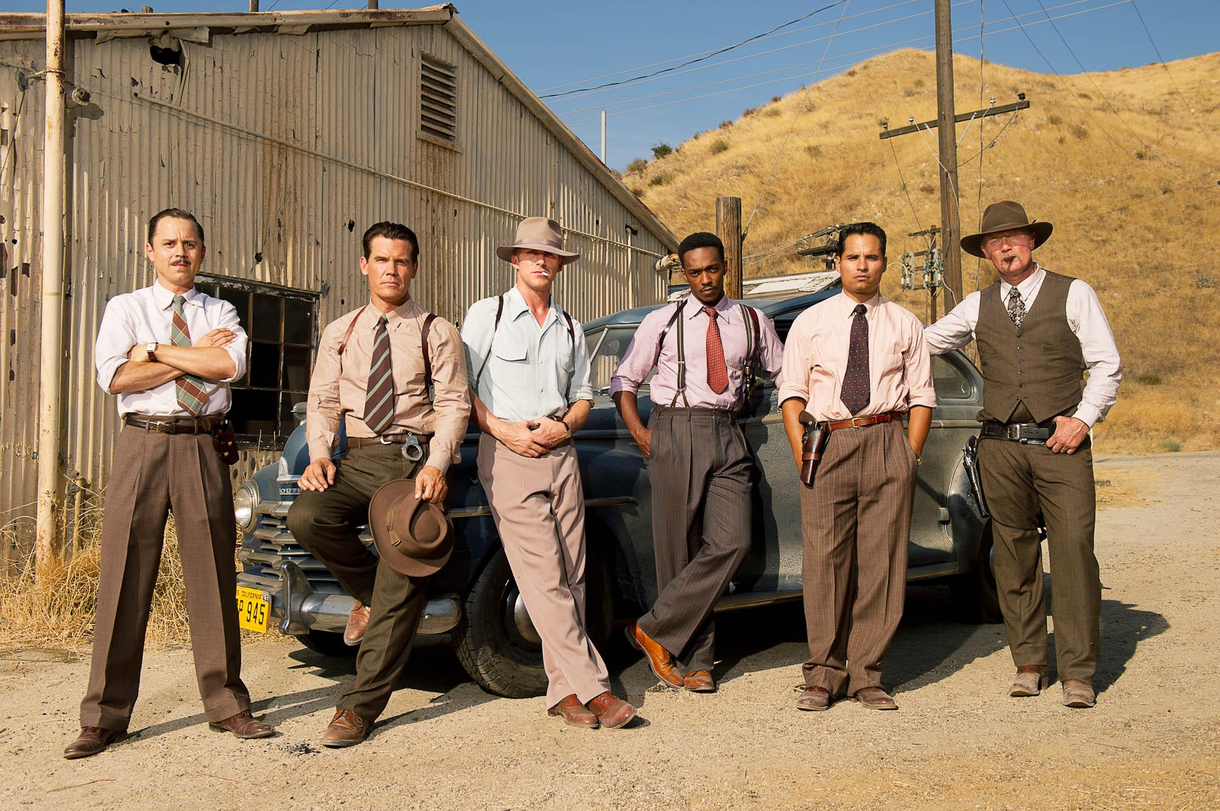

Figure : Informal appearance. A sense of authority, but the lack of jackets appear as though the individuals are out and about, conducting police duties.

Figure :

* Height
  + 1.8 meters tall
* Movement
  + Moves at a rate of 2 meters per second
  + Chases the player if within 20 meters of the player
* Attacking
  + Armed with a baton
    - Attacks once every 2 seconds if within 2 meters of the player
    - Attacks deal 12 damage
    - Damage is dealt in a 180* arc in front of the character model, with a range of 2.5 meters, dealing damage if the player is within.
      * For example, this arc - from the Cop_Melee’s perspective - is drawn from its left side at 270* azimuth, to 90* azimuth.
* Hitpoints
  + 130
* Death
  + Awards 1 soul to the player upon death.
  + Character model is destroyed and replaced with gore pile.

### Software Level Systems

#### Level loading

* Scenes
  + Each level is a separate unity scene, and is loaded when player walks into a collider which checks if certain criteria have been met before loading.

#### Collections

* Armor
  + The player will pick up the armor in the first exhibit room before exiting the museum.
  + The player is alerted to the armor by pulsing arrows on the floor, pointing to the armor display case.

#### 

# Interface

## Menu Screens

### Main Menu

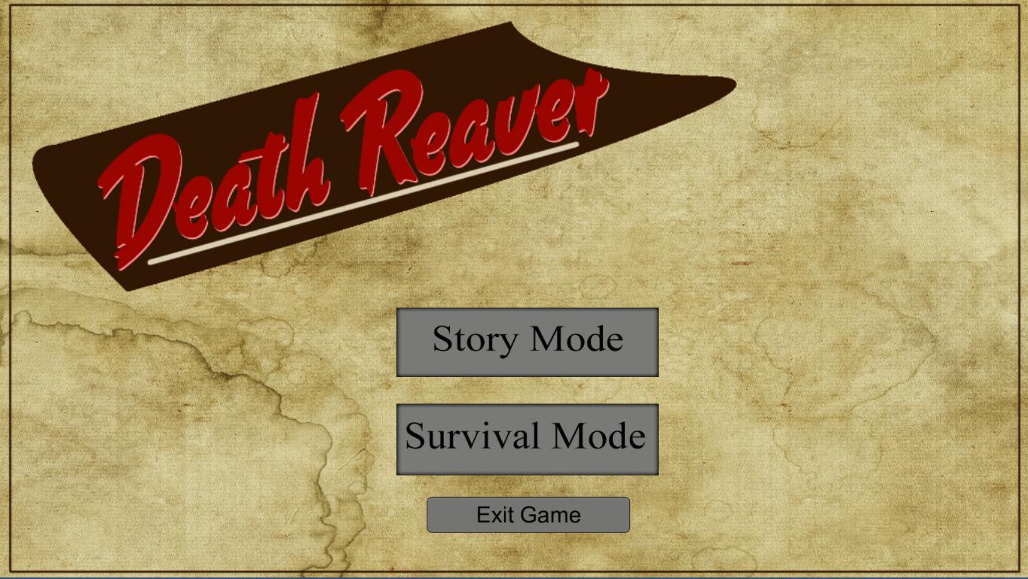

### Pause Screen

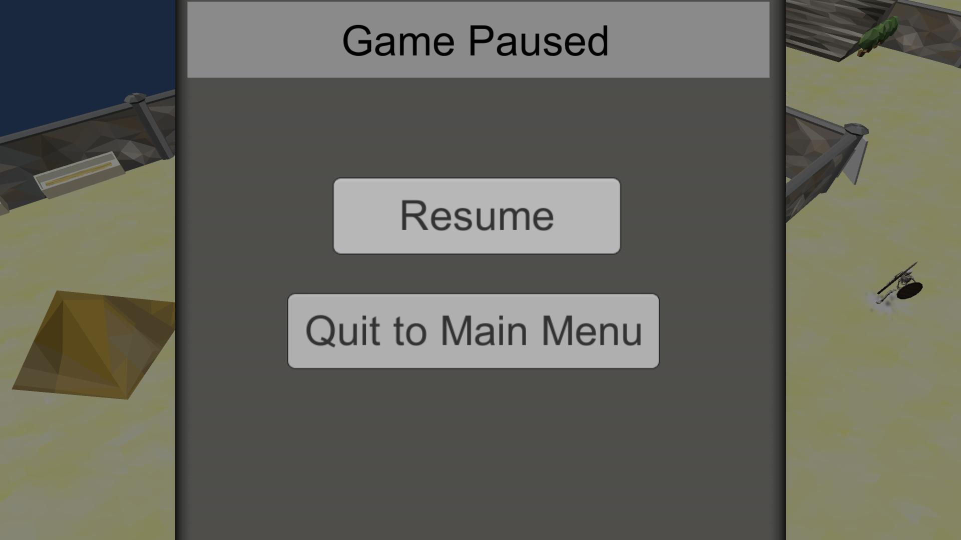

### Character Talent Sheet

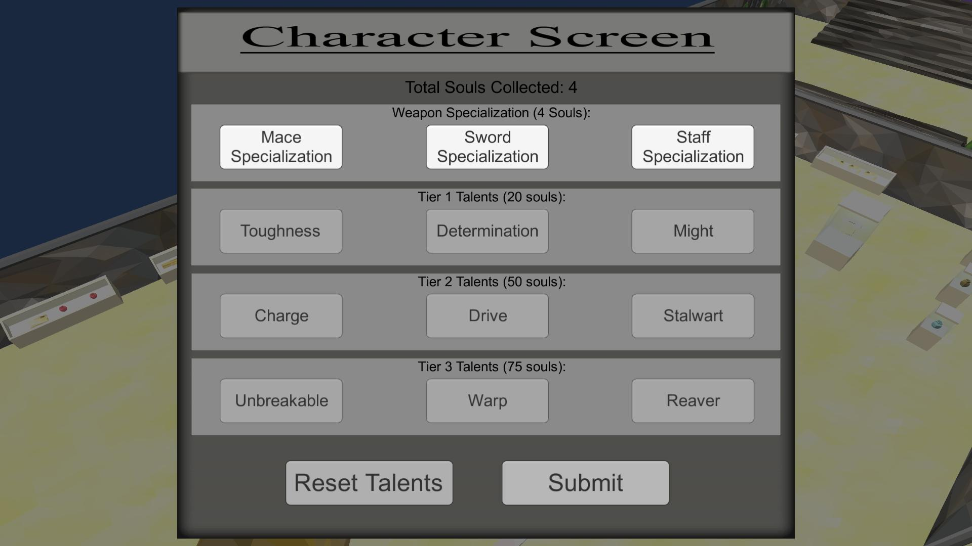

### Game Over

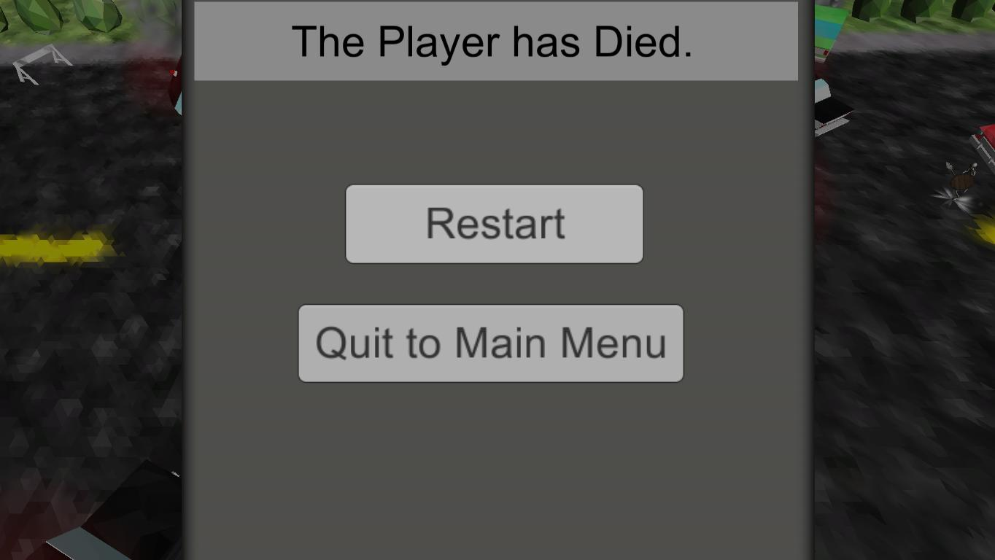

### Controls menu

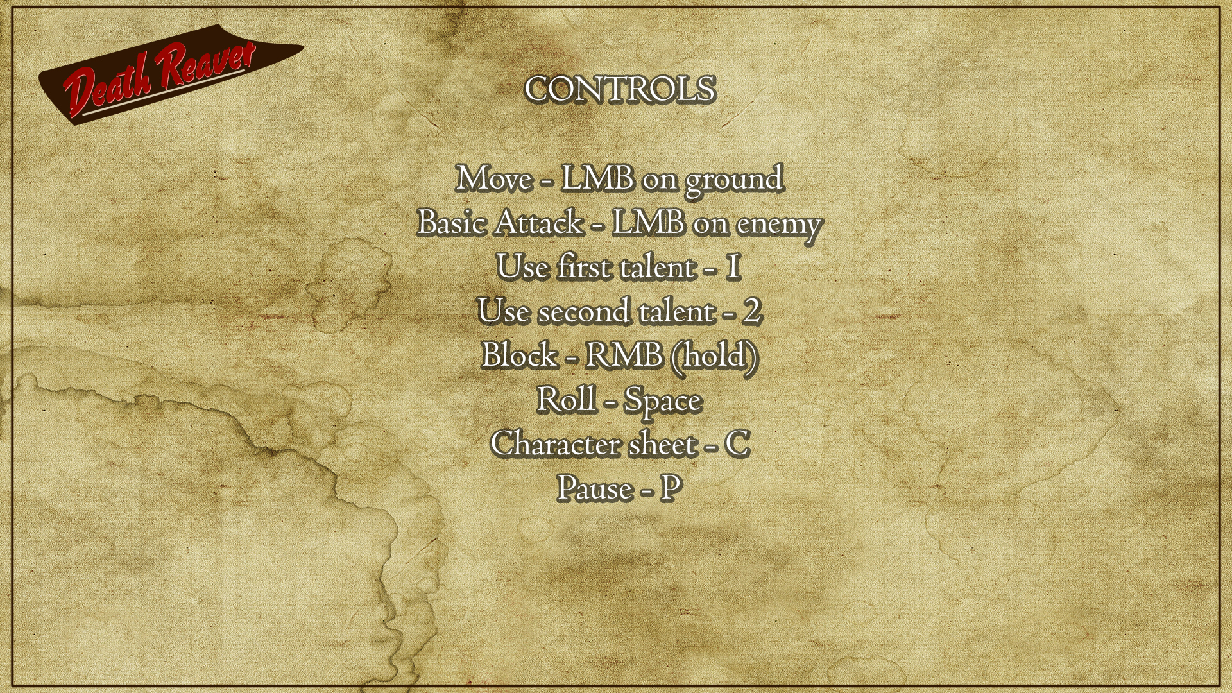

## HUD

### Stats panel

Player Health is displayed in a green bar, with the values underneath.   
  
Souls captured are displayed in a blue bar, with the current value out of the total needed to advance to the next tier of talent choices

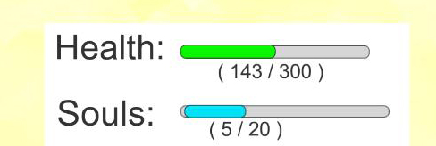

### 

# Environment

## Level Breakdown

### Museum Lab

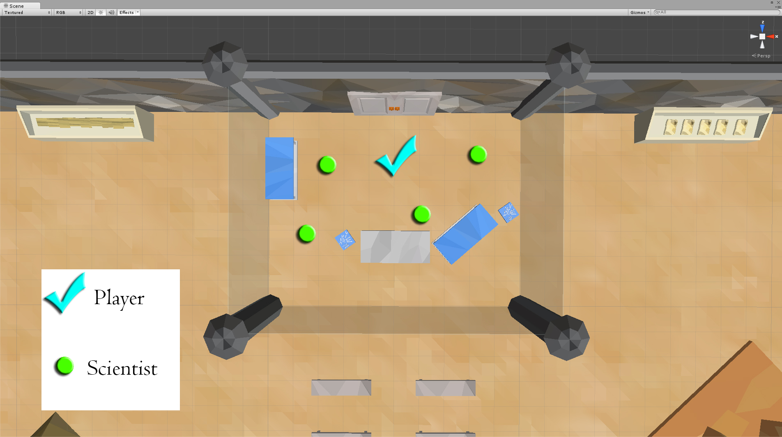

In scene 1, the player is locked in the lab, with the ability to see into the exhibit area. The player will kill the scientists within the lab, collect their souls to unlock the first talent, and then load the next scene by triggering the glass to break when near it.

### Museum Interior

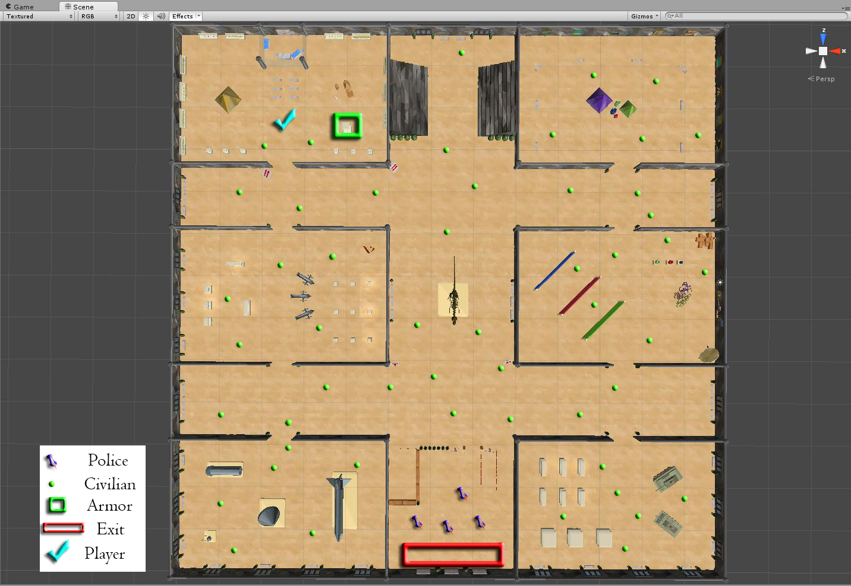

In the main museum halls, the player levels up on humans found throughout. The player exits the museum at their leisure, on the southern end, after acquiring the armor pick pick-up.

### Museum Exterior

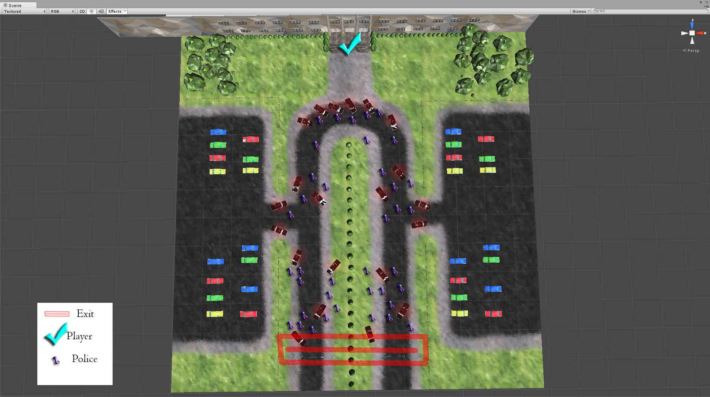

The player fights their way down either side of the drive way, killing police armed with pistols and submachine guns along the way, and ends the game by reaching either end of the driveways on the south side.

**Soul Harvest**

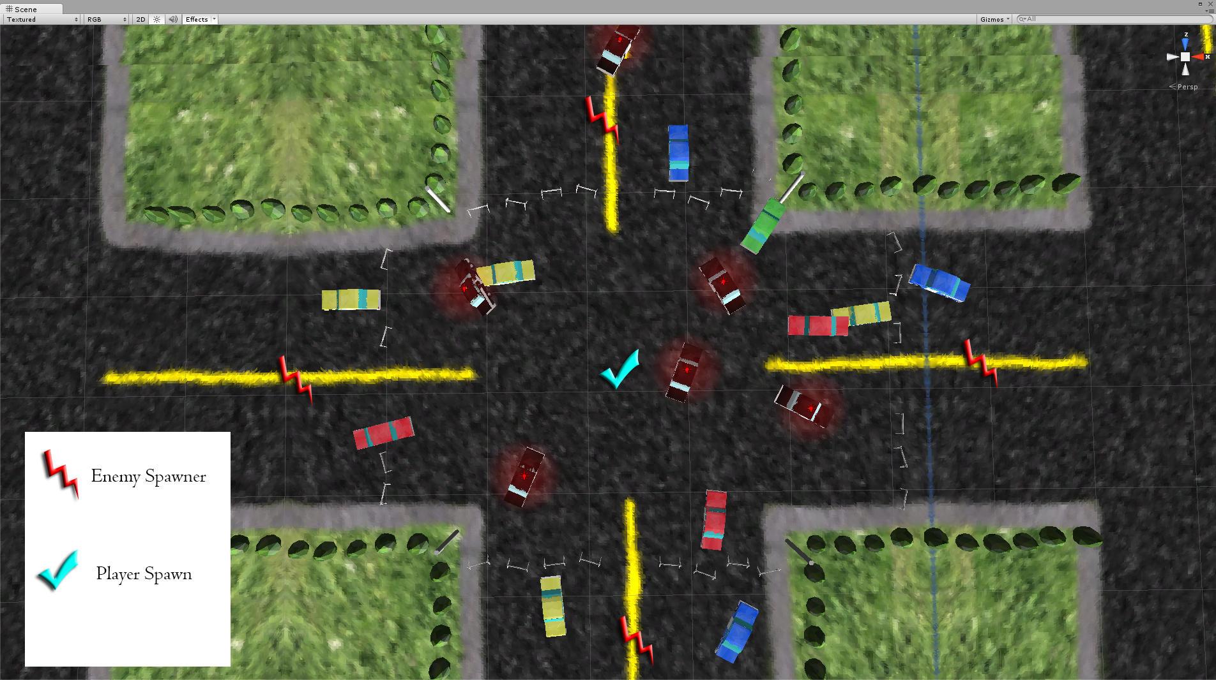

The player spawns in the center of the intersection, and remains within the police barricade lines. And infinite number of enemies spawn at the north, south, east, and west roadways, and attack the player.